A Summary of Benefits of Probiotics in Human Gut
Student’s Name
Institutional Affiliation

A Summary of Benefits of Probiotics in Human Gut
Probiotics are defined as living microorganisms that are intended to have health benefits when consumed or applied to the body. They can be found in yogurt and other fermented foods, dietary supplements, and beauty products. The importance of keeping a healthy microflora was already clear at the beginning of the twentieth century when consumption of yogurt and a specific mix of bacteria were associated to extended lifespan and prevention of disease. These observations have been the driver for the development of probiotics defined as “live micro-organisms which, when administered in adequate amounts, confer a health benefit on the host” (Roselli et al, 2017). A large variety of probiotics are available on the market and generally they are consumed to target gastrointestinal discomfort and pain as well as to improve the properties of the immune system.
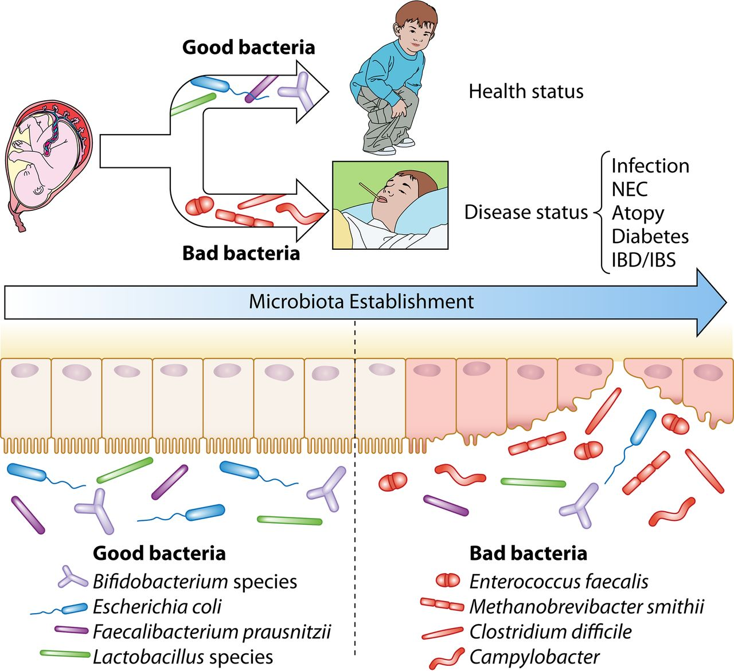
Being the largest interface between the body and the external environment, it is not surprising that the GIT is tightly associated and constantly in communication with the immune system. Intestinal bacteria develop and regulate the host immune system and the immune system affects the composition of the intestinal microbiome. In particular, the host immune system is responsible for ensuring a beneficial microbiota composition controlling specific bacteria overgrowth, but also reacting to pathogenic bacteria or molecules meeting with the intestinal barrier (Pagnini et al, 2010).
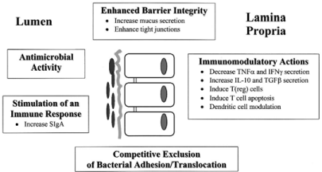
The interaction between immune system and pathogens is also regulated by microorganisms that can directly interact with pathogenic bacteria or indirectly stimulate the immune system to do the same.
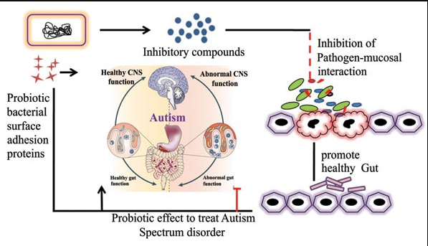
Gut homeostasis is, therefore, reached and maintained when the immune system establishes an appropriate balance between tolerance to commensal, mutualistic, and opportunistic bacteria (Pagnini et al, 2010). This balance is consolidated only when the immune system can communicate with the gut microbiota and a key player in this cross-talk process is a healthy intestinal barrier. 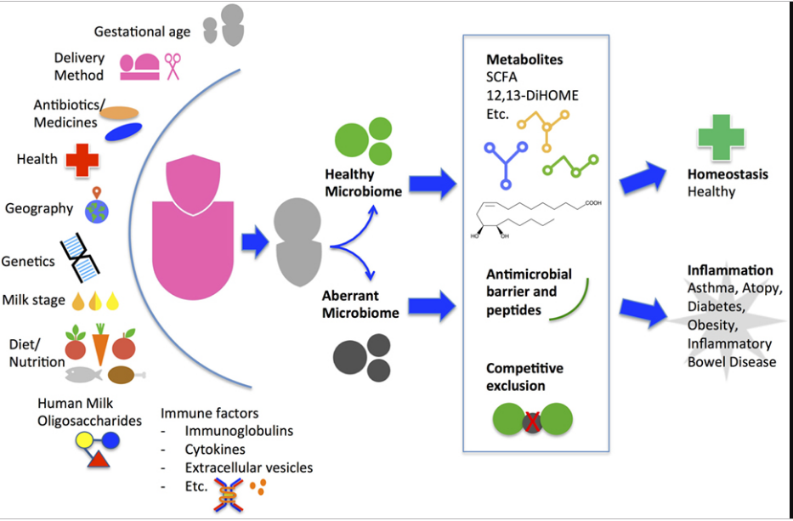

References
Pagnini, C., Saeed, R., Bamias, G., Arseneau, K. O., Pizarro, T. T., & Cominelli, F. (2010). Probiotics promote gut health through stimulation of epithelial innate immunity. Proceedings of the national academy of sciences, 107(1), 454-459.
Roselli, M., Pieper, R., Rogel-Gaillard, C., de Vries, H., Bailey, M., Smidt, H., & Lauridsen, C. (2017). Immunomodulating effects of probiotics for microbiota modulation, gut health and disease resistance in pigs. Animal feed science and technology, 233, 104-119.

